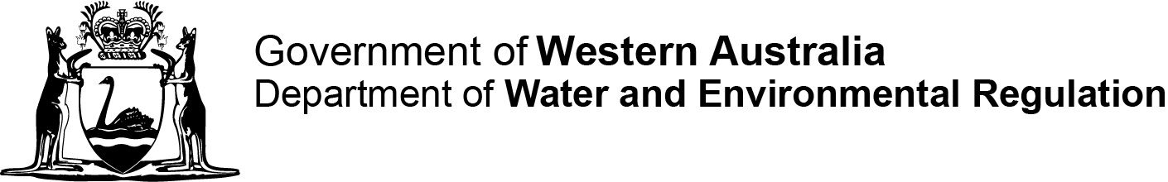

Ref No.

Contaminated sites auditor scheme

Contaminated Sites Regulations 2006 regulation 36(1)

Form A: Application for first time/primary accreditation

|  |
| --- |
| This form is for **first time accreditation**. Please also complete and attach **forms D, E and F**. |

|  |  |
| --- | --- |
| **Part 1 Applicant details** | |
| Full name |  |
| Contact address |  |
| Postal address  (if different from above) |  |
| Telephone |  |
| Mobile |  |
| Email |  |
| Current employer (company name) |  |

|  |  |  |
| --- | --- | --- |
| **Part 2 Required supporting information/documentation** | | |
| This application will not be processed without the following documents being attached/completed. |  |  |
|  | Yes | No |
| Original statement addressing all relevant elements of the selection criteria detailed under sections 4 and 5 in Accreditation of Contaminated Sites Auditors (DWER, 2024) | ☐ |  |
| Copy of current curriculum vitae and certificates of educational/professional qualifications and membership of professional associations in Australia |  |  |
| Project synopsis |  |  |
| Form F, permission to reference client reports and copies of the relevant reports |  |  |
| Payment details for the application fee ($440) | ☐ | ☐ |
| Details of your current auditor [civil liability] insurance (refer regulation 59A of the Contaminated Sites Regulations 2006), or do you undertake to obtain such cover if the application is successful? |  |  |
| Details of your supporting experts (refer Form D) |  |  |

|  |
| --- |
| **Part 3 Declaration and signature** |
| Under the *Contaminated Sites Act 2003*, s71, it is an offence to obtain or attempt to obtain accreditation as an auditor by:   * providing information which you know is false or misleading in a material particular * providing information that is false or misleading in a material particular, with reckless disregard as to whether or not the information is false or misleading in material particular * failing to disclose information that you know is materially relevant. |
| **I declare that the information in this form, and provided with this form, is true and is not misleading in any material particular and that I have disclosed all information that I know is materially relevant to this application.**  ________________________________Date Click here to enter a date.  (Applicant’s signature)  ________________________________  (Full name in block capitals) |

**APPLICATION FEE FOR FIRST TIME/PRIMARY ACCREDITATION**

**Form A [r. 36(1)(c)]**

**Contaminated Sites Regulations 2006, regulation 36(1)**

**PAYMENT FORM / TAX INVOICE ABN: 28 420 443 065**

|  |  |  |
| --- | --- | --- |
| **PAYMENT METHOD** | | |
|  | Credit card payment (online) – access DWER payment portal and select Contaminated Sites (Biller Code 1568872). Please include:   * Full name * Company name * Your reference   Before submitting the application, record the receipt number and payment date below. | |
| **Bpoint receipt no:** | | Date paid: |
|  | EFT/bank transfer – BSB: 066040 Account No: 018300113 Name of Bank: Commonwealth Bank of Australia  Please include in the description:   * Form A and your reference number   Please send remittance advice to: [accounts.receivable@dwer.wa.gov.au](mailto:accounts.receivable@dwer.wa.gov.au) and [contaminated.sites@dwer.wa.gov.au](mailto:contaminated.sites@dwer.wa.gov.au) | |
|  | Cheque/Money order   * Make payable to Department of Water and Environmental Regulation | |

**Email completed form to:** [**info@dwer.wa.gov.au**](mailto:info@dwer.wa.gov.au)

**If paying by cheque/money order, please mail completed form to:**

**Manager, Contaminated Sites Branch**

**Department of Water and Environmental Regulation**

**Locked Bag 10**

**Joondalup DC WA 6919**

**Important:** If lodging your Form A by mail, please do not send cash through post.