 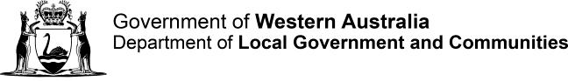

# Department of Local Government and Communities - Cloud Transition Case Study

The Department of Local Government and Communities (DLGC) has been progressively adopting agile software development methods while increasing the use of DevOps tools and processes across ICT.

We are sharing the department’s experiences so agencies considering a move to both Agile and DevOps will be able to determine the potential value to your organisation. We welcome the opportunity to talk with you and share more of the department’s ICT journey.

It should be noted that while most of this case study focuses on technical aspects; moving to Agile and DevOps is a journey. The Business Systems team quickly determined that the move to agile required the team to adopt a disciplined approach to agile methodology and application, and understanding the prescriptive nature in regards to user stories and ceremonies. Moving to DevOps also requires a relatively large culture change along with a paradigm shift. It began as a journey that all of ICT are now on together and heading in the same direction.

## Background:

In early 2015, Richard had somewhat of a unique opportunity to participate in two website development projects at the same time. What made this unique was that one project was developed using the traditional waterfall approach while the second was developed using agile/scrum. This afforded the opportunity to compare and contrast the two methodologies in practice at the same time.

Website 1

* Traditional Waterfall
* Upfront workshops for requirements
* Elongated Feedback Loop
* Manual Deployments

Website 2

* Agile/Scrum
* Ongoing Workshops
* Daily Standups / Two Week Sprints
* Scripted Deployments

It soon became apparent that although different to what the department had done previously, the agile project was transparent and business focused simply by the nature of agile ceremonies such as stand- ups, demonstrations and retrospectives.

Another difference in the projects was that one was configured to deploy using mainly automated scripts and the other was very much a manual deployment. Automated deployments were less stressful and repeatable, where the manual deployments consisted of many steps (automated and manual) and a traditionally large deployment guide. The latter method is more prone to human error and introduced not only increased risk but also an elevated level of stress on the infrastructure team when deploying to production.

These key differences were the influencing factors in Richard’s decision to have the Business Systems team transition to agile software development.

## An opportunity to modernise:

In December 2015, the department began work on what was to become the [MyCouncil](https://www.mycouncil.wa.gov.au/) website. The department took this opportunity to not only develop the website using an agile methodology, but to also utilise Platform as a Service (PaaS); Azure Websites and Azure SQL to host the website and associated databases. The result was freeing up the infrastructure team from having to maintain those servers in the department’s environments.

This afforded the department an opportunity to use the new release management tools and service associated with our [Visual Studio Team Services (VSTS)](https://www.visualstudio.com/vsts-test/) account where both code artefacts and the Business Systems team’s backlog of work are also stored.

Using release management and PaaS meant that the department could execute one click deployments through Dev/Test/Pre-Production, and then through to Production with gated approvals to maintain appropriate governance. Each time a deployment is made the website is automatically rebuilt from code and deployed to the appropriate environment.

Additionally, as the servers are using Azure Resource Manager (ARM) templates, Disaster Recovery for this website was taken care of; each environment is scripted (infrastructure as code) and can be recreated in a matter of minutes. It is then followed by redeploying the latest version of the code to the new environment, and running some additional scripted ETL processes to populate the data marts. The entire process can be completed in **less than two hours**.

The outcome for the department was a website developed on time, under budget and with a high degree of confidence that it would deploy to production with no issues or stress.

## Performance scaling in the cloud:

The site was deployed as scheduled and with no issues. Strong media coverage caused the site to be placed under heavy load, and started to experience some degraded performance even though load testing had been performed as part of the deployment process. The decision to install application insights allowed the department to quickly pinpoint the issue. As the site is hosted in Azure using PaaS, it was a simple matter of upscaling one of the SQL servers to accommodate the increased load.

This required selecting the next higher performance database instance in our management portal and was done in **less than two minutes** of down time for the website. The site did not experience any further issues.

## Celebrate success:

The [MyCouncil](https://www.mycouncil.wa.gov.au/) website was the cornerstone of a larger portfolio of work accomplished by the department, and was subsequently awarded the **2016 Premier's Award** in the category of Improving Government and Reducing Red Tape. Success was largely attributable to two extremely motivated and dedicated partners from two areas: Richard and an officer from the Community Building and Services Division. Both officers were highly involved in all stages of the agile development process. Overall, there was very little re-work and the result was an excellent outcome for the department.

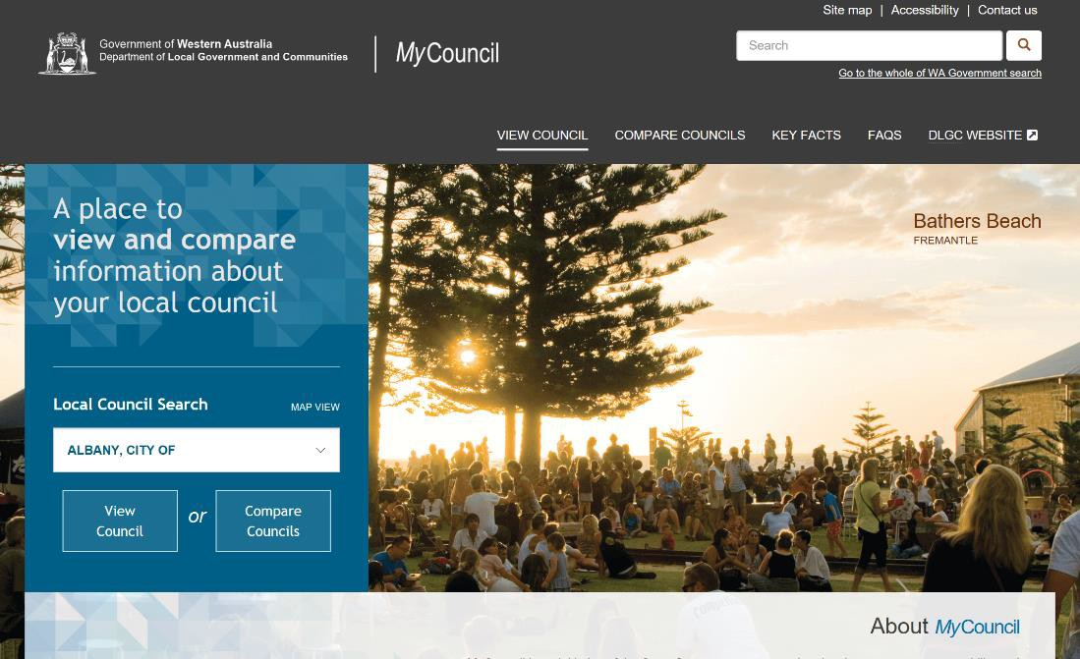

*The MyCouncil Website*

For those who follow Gartner and the concept of Bi-Modal IT, this would be an example of a highly successful mode two project.

## Addressing Pain Points - SharePoint

Building on the success of the MyCouncil Website, Richard identified areas for which the department could improve processes while reducing risk. There was no better place to start than a major pain point that is **SharePoint deployments**.

Working with partners, the Business Systems team created a Continuous Integration and Continuous Deployment (CI/CD) pipeline for SharePoint development and deployments.

1. First step was to standardise a branching strategy (minimal branching) so that when a developer checks in code (tied to a work item) into the development branch that it starts a CI build and deploys the code to their local instance.
2. Upon merging the code to the main branch, it automatically starts the CD process where the changes are deployed to the test environment.
3. an email is generated to Manager, Business Systems and the Manager, IT who then authorises the deployment to move to Pre-Production.

Note: these deployments require no intervention from either Dev or Ops as teams create SharePoint lists and web parts using code.

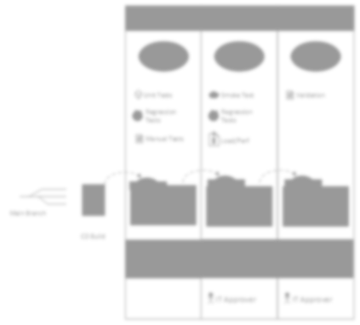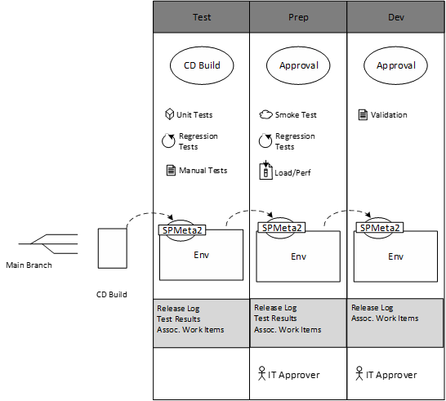

## Standardising practices across the entire application development stack:

As a medium sized agency with limited developer resources and budget, the department engages with external consultants (partners) for both software development and some infrastructure services. This presents both opportunities and risks in that no two consulting agencies do things the same way. In order to mitigate this, Richard instituted a series of governance measures that require our partners to not only follow their ‘best practice’; but to adhere to the department’s requirements; increasing governance in order to reduce risk.

The department’s partners must follow internal development processes:

* All code must be held in the DLGC VSTS tenant and checked in nightly
* Associate every check-in with a Work Item (PBI, Bug or Task)
  + It provides build history
  + It creates automatic release notes
* Solution installation should be scripted
  + Re-running the installation should update any changes and
  + It does not overwrite existing unchanged components
* Plan for automated deployment
  + Environment variables should be configurable

A member of the Business Systems team is also now assigned to all projects involving external partners to ensure that a transfer of knowledge occurs, and to assist them in adhering to departmental procedures.

The department’s strategic decision to transition to agile software development and DevOps has not only increased productivity, but has seen a reduction in risks associated with software development and release management.

The product results in ICT having end to end traceability for work items, including the ability to see at a glance what changes have been deployed to what environment. Below are screen shots of a changeset tied to task assignments and the DevOps release management dashboard:

*A note about infrastructure:*

All Infrastructure is now in Azure IAAS. Developer Machines, and the Test Environment is scripted to shut down every evening at 7PM to save costs. Test restarts at 7AM and developer machines must be restarted by developers as needed. DLGC IT has embraced the same DevOps toolsets and all server builds are now scripted.

*Scaling Beyond ICT*

Striving for even more innovation using agile techniques, Richard actively engaged the Executive Director, Corporate Services and CIO; successfully seeking a way to scale agile processes beyond ICT. After many discussions including an executive briefing from Gartner Research and Advisory service with Directors, Richard initiated a training session in the agile methodology for an audience that was non-ICT, and to be involved in Corporate Services on-line forms initiative.

Members from Human Resources, Finance, Governance and Corporate Communications would be active members in this cross functional agile team; attending daily stand ups and participating in sprint planning and retrospective meetings.

As not everyone on the team operated within Visual Studio and VSTS, it was decided to use a physical Kanban Board as well as a virtual board. This board is located in the open space of the Corporate Services area where the daily stand up is held so that the entire division can see the team’s progress.

By working in a cross functional agile team, previous information and communication silos have been broken down and a new spirit of collaboration has taken hold across the whole of Corporate Services. Branches within the division are now actively looking for other opportunities to work together.

*Where to from here?*

ICT have a further set of associated goals they are committed to achieve in the near-term:

* Implement a similar CI/CD Pipeline for Dynamics CRM
* Implement DevTest Labs in a meaningful way to give developers more options and freedom to experiment.
* Become more proficient at writing coded UI tests to further increase quality.
* Progressively move to ARM templates by default for infrastructure and experiment with Desired State Configuration (DSC).
* Continue the DevOps journey.

*Strategic Outlook:*

With the advent of Digital WA: Western Australian Government ICT Strategy 2016 – 2020 and the Digital Services Policy, it is clear that all public sector agencies are now required to become digital.

The initiatives above, along with others have been instrumental in creating a digital platform from which the department can now embrace **digital by design** and **digital by default**. This allows the department to plan for improved service delivery to the community of Western Australia in a way that they have become accustomed to; digitally, on their terms, on any device of their choosing, and in a safe and secure manner.

By building this digital platform, the agency is now able to stop thinking about one off projects and concentrate on continuously improving its product offerings; Grants, Seniors, Parenting, Youth, Volunteering, Carers or Local Government, and with a long term digital vision for the future. It also enables the department to focus more on the digital ecosystems it establishes, or is part of; whether that is exchanging data with other agencies automatically, or having a true 360-degree view of its stakeholders.

This successful foundational work is transforming DLGC into a truly Digital Public Sector Agency.

For further information contact Richard Bean – Manager, Business Systems, ICT, Corporate Services, Department of Local Government and Communities [richard.bean@dlgc.wa.gov.au](mailto:richard.bean@dlgc.wa.gov.au)