# Enterprise Architecture

# in the Public Service

Using Enterprise Architecture to improve business outcomes and support digital transformation in the public sector.

December 2017



Western Australian Enterprise Architecture Framework (WEAF)



## Background

Enterprise architecture, or EA, is a practice – much like project management or business analysis – that is used within ICT organisations to obtain better outcomes. EA is a powerful tool to understand and communicate what an agency does and how it uses its information, applications and technology to carry out its functions. When used properly by trained practitioners, EA can also help agencies to better plan what they need in the future, and how they can effectively work with other agencies to achieve common goals faster, at lower cost, and with less risk.

The [Western Australian Enterprise Architecture Framework (or WEAF)](https://www.wa.gov.au/government/publications/wa-enterprise-architecture-framework) combines existing standards with local expertise to provide contextualised guidance for agency ICT organisations to operate effective EA practices and increase the perceived and actual business value they deliver to their Executive and the rest of their agency.

## The Value of Enterprise Architecture

In order to have justified confidence that their ICT investment effectively and efficiently supports agency priorities, executives need to know that ICT management and staff:

* understand the strategic business outcomes required by the agency;
* have the right capabilities to meet agency expectations or the ability to identify any gaps and propose ways of developing them;
* undertake operations that are mature enough to be measured against the KPIs of both agency and whole of government ICT strategies, policies and initiatives; and
* are collaborating across the public sector to identify, leverage and source capabilities and resources that are already in use at other agencies.

Enterprise architecture provides the tools, disciplines and guidelines that, if implemented properly, will enable a Chief Information Officer (CIO) or ICT Manager to clearly and understandably provide this level of confidence to their Corporate Executive.

## The Benefits of Enterprise Architecture

From an agency perspective, EA offers four main benefits – business agility, better collaboration, improved delivery, and clearer directions for planning.

### Business Agility

EA enables ICT (and the rest of the business) to clearly understand and document an agency’s internal capabilities, functions and relationships. When this is done across the public sector, it also allows agencies to easily discover and understand the capabilities of other agencies and – more importantly – where those capabilities overlap or can be leveraged. Agencies with this information can be more agile, flexible and adaptive in how they deliver government services. If an agency knows its own capabilities and what it can leverage from other agencies, it can better respond to and plan for change.

### Better Collaboration

Collaboration is only possible if decision makers see a benefit to collaborating with other agencies. EA provides a way to explore and discover capabilities across the public sector to support informed decisions on the benefits of potential collaborations. It does this through a common language and process to identify and describe capabilities such as business functions, data, applications and technology. The WEAF uses a taxonomy that describes government capabilities developed by the Commonwealth Government and adopted by multiple states across Australia.

### Improved delivery

The primary purpose of EA is to improve the likelihood of successful business outcomes. Through promoting re-use of existing standards, assets, information and other capabilities, EA assists with project prioritisation by helping to identify the projects that are most needed and aligned to agency strategic objectives, as well as those most likely to deliver the shortest and/or best return on investment.

### Clearer directions for planning

EA provides tools and techniques that help agencies maintain their focus on the big picture throughout major changes (such as Machinery of Government changes) or significant digital transformations (as indicated by the Digital WA State ICT Strategy[1]). Once fully implemented it can provide agencies with a high level of confidence that they are investing in the right projects to deliver both their own strategic objectives, and supporting whole of government strategic objectives.

Figure 1 (right) places EA within the context of an agency’s governance structure. While the Director General or Chief Executive Officer sets the strategy, and senior management are responsible for undertaking projects and activities, EA supports the Executive Management team to know that the right projects and activities are being undertaken, and that they align to the approved strategic goals.

Enterprise architecture is about making sure you’re doing the right things, while project management (for example) is about making sure you’re doing things right.

### The Role of Enterprise Architecture

[Digital WA, the State ICT Strategy](https://www.wa.gov.au/government/publications/digital-wa-state-ict-strategy-2016-2020) states that:

*“With more than one hundred different agencies delivering a wide range of services to the community, the public sector is both large and complex. Even though agencies have different purposes and provide different services, there are a range of business functions that are common across the sector, such as licensing.”*

and:

*“Agencies will be able to use newly defined frameworks delivered by the Strategy, such as a Government Enterprise Architecture, to decide where ICT resource investment should be prioritised, and identify any opportunities to obtain greater value.”*

This was expressed through Figure 2 (below) which highlighted two key points. Firstly, agencies need to identify when technology can be most effectively and efficiently obtained “as a service” instead of purchased or developed as a capital expense. Secondly that agencies need to identify when a function they carry out (and hence use technology to support) is not actually unique to them but rather is very similar to functions carried out by other agencies.

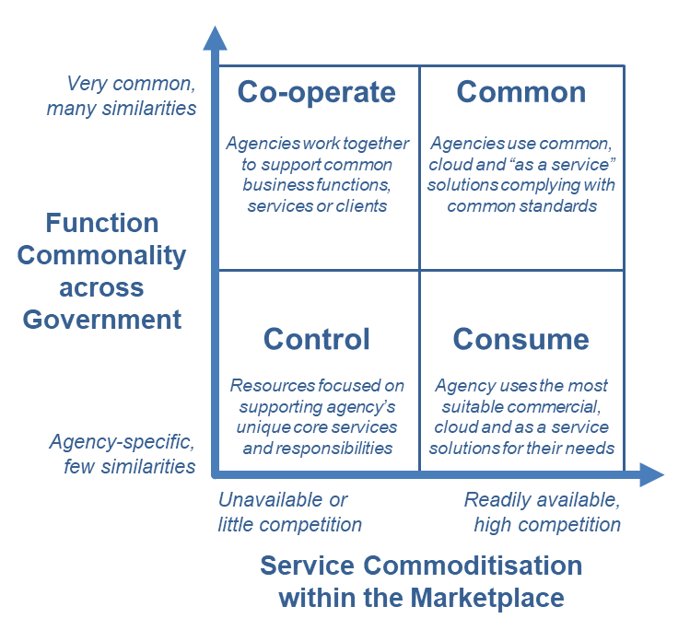

Figure 2.

EA is the only discipline that clearly and effectively allows an agency to identify functional, informational and technology similarities with other agencies in a structured and actionable manner.

By implementing EA effectively across the public sector, agencies will be able to leverage existing and shared resources, and divert more of their budget to support those functions that are truly unique and make up the “core business” that they must control.

### The Future of Enterprise Architecture

[The Western Australian Enterprise Architecture Framework (WEAF)](http://www.wa.gov.au/government/publications/wa-enterprise-architecture-framework) is an over-arching framework that provides all agencies with a common standard and approach to undertaking the practice of enterprise architecture.

We will continue to develop the WEAF during 2017-18, the following actions will be planned or undertaken during 2017-18:

1. Development of a whole of government Enterprise Architecture Repository to record the documented capabilities and resources of each agency and allow agencies to discover and identify capabilities to leverage and opportunities for collaboration;
2. Develop a whole of government Enterprise Architecture Working Group that reports to the CIO Advisory Committee and Business Impact Group, to develop and refine processes to leverage common capabilities such as identity management and secure data sharing;
3. Work with agency CIOs to assist them in developing their EA capability through workshops, education and advisory services; and
4. Measure the acceptance and implementation of EA across the public sector as part of the 2017-18 OGCIO KPI data collection.

### Implementing Enterprise Architecture

EA adoption within agencies will not be without challenges, and will take time and effort. Both ICT and non-ICT management within an agency will need to understand the practice and adopt it within their current projects and – where suitable – operational activities.

EA is not a “magic bullet” that will – by itself – ensure ICT projects and services are successful. To ensure long-term strategic goals are achieved, agencies also need good program / project management and robust ICT service delivery management. EA bridges the gap between business strategy and the execution of that strategy. When properly implemented it will allow agencies to realise the benefits of digital transformation with more certainty and confidence, as the agency can have a high degree of certainty that they have the right capabilities in place.

To realise the benefits that effective enterprise architecture can provide, agencies should:

1. adopt the WEAF according to business needs, priority, funding and desired benefits;
2. reorganise their ICT governance to ensure that senior business decision makers know what ICT capabilities the agency already possesses, and how they align and support the agencies strategic direction both now and in the future; and
3. work with other agencies and the OGCIO to help leverage the ICT investment of the sector for the benefit of the Western Australian community.

1. *Digital WA: Western Australian Government State ICT Strategy 2016 – 2020*, May 2016, Office of the Government Chief Information Officer, available at http://gcio.wa.gov.au/wp-content/uploads/2016/05/ICT-Strategy_Web_compress.pdf